Ideation Phase
Empathize & Discover

Date | 31 January 2025
Team ID
Project Name | Freelance Finder
Maximum Marks | 4 Marks

Empathy Map Canvas:
Understand the needs, frustrations, and behaviors of airline passengers using a flight ticket booking app to plan their travel efficiently.
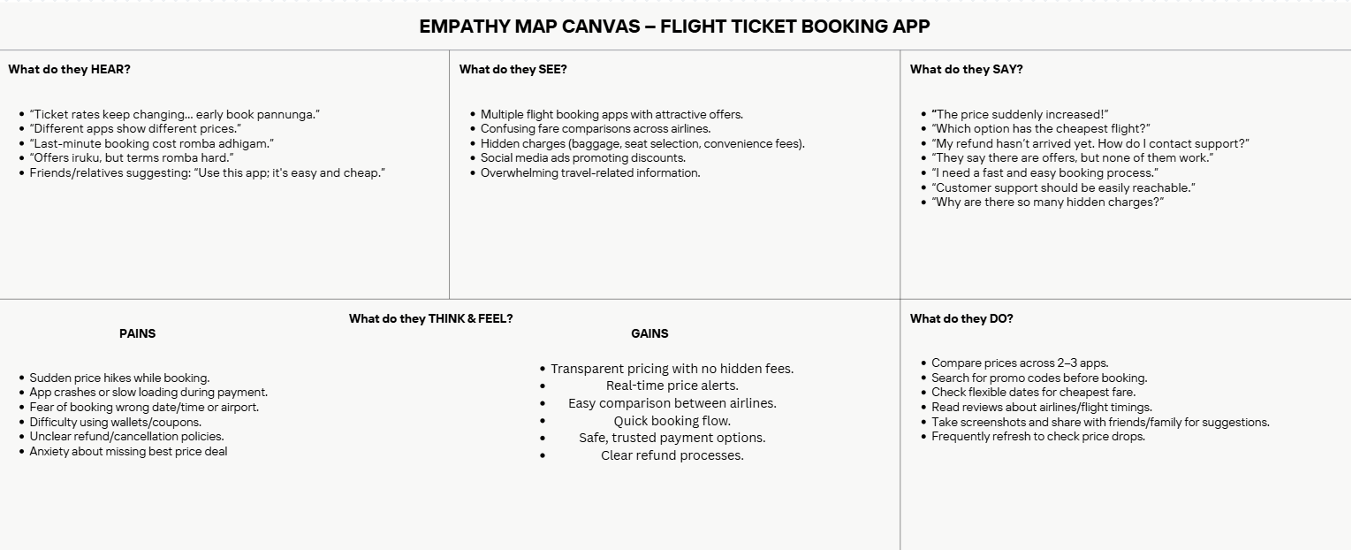

seeking consistent work through a platform like Flight Ticket Booking App.

